Ancient Arts Holistic Veterinary Services, PLLC
PLEASE PRINT LEGIBLY
Return completed form to clinic one week prior to appt. via fax 206-547-1325 or email AncientArtsVet@gmail.com
If you arrive without completed paperwork, the time taken to fill out the forms will take away from doctor time.

Name of Human Guardian, Partner/Co-owner (if applicable) & Preferred Pronouns:
________________________________________________________________________
Home & Mailing Address (if different): ________________________________________
City/State/Zip: ___________________________________________________________
Main Phone Number: __________________ Secondary Number: _________________
Email Address: ___________________________________________________________
Emergency Contact: Name & Preferred Pronouns, Relationship to owner, and Number: ________________________________________________________________________

Pet’s Name: __________________________ Breed: ____________________________
Age & Date of Birth: _____________________ Sex: _______ Spayed/Neutered?: ______
Color/Markings: __________________________________________________________
Approximate Weight: __________________

Have there been any recent changes in:
Weight: _____________________________ Mood: _____________________________
Thirst: ______________________________ Appetite: ___________________________ Urination: ___________________________ Defecation: _________________________

Have there been any signs of: (circle all true)
Vomiting| Regurgitation | Diarrhea | Constipation | Incontinence | Coughing | Sneezing

Today’s visit is to treat: ____________________________________________________
________________________________________________________________________
Specify your goals for treatment: ____________________________________________
________________________________________________________________________
________________________________________________________________________
Prioritize, from most to least important, the issues that you would like addressed
________________________________________________________________________
________________________________________________________________________
________________________________________________________________________
What diagnostics have you pursued for these issues. Also, when and where were they done? (If it has been too long they may need to be rechecked)
________________________________________________________________________
________________________________________________________________________
________________________________________________________________________
If you didn’t inform us of these on your intake call, please have them sent our way ASAP!!!

When & where did you get your pet? _________________________________________

Is your pet aggressive toward: (circle all true)
Dogs | Cats | Animals | Men | Women | Kids
Has your pet ever bitten or scratched anyone
Yes | No
Has your pet ever required sedation for any routine procedure? (i.e. dental cleaning, toenail trim, etc.) ________________________________________________________________________
Have there been any significant medical issues in the past? (i.e. surgeries, accidents, vaccine reactions, noise phobias (e.g. vacuum), separation anxiety, etc.) ________________________
____________________________________________________________________________
____________________________________________________________________________
Last vaccines given: _______________________________________________________
Frequency and types of vaccines and dewormings/fecals given to pet throughout lifetime: _____________________________________________________________________________
Flea control, type & frequency: ______________________________________________
What kind of food does your pet get? ________________________________________
Supplements? ___________________________________________________________
Treats? _________________________________________________________________
List all medications and dosages: ____________________________________________
________________________________________________________________________
________________________________________________________________________
Are you capable of giving medication to your pet in the form of: (circle all true)
Pills | Liquids | Powders in Food

Exercise type & frequency: _________________________________________________
Playtime type & frequency: _________________________________________________
Has your pet traveled/lived outside of this area? (List where, when, & for how long)
________________________________________________________________________
Are there other pets in the house? ___________________________________________
________________________________________________________________________
Do all your pets get along or are there conflicts? _______________________________
________________________________________________________________________
Is anyone in the house having similar symptoms or significant illness? ______________
________________________________________________________________________
Have there been any changes in the household recently? ________________________
________________________________________________________________________
How did you learn about Ancient Arts? _______________________________________
Primary Care Veterinarian & Clinic: ___________________________________________

Please shade in the areas on the chart where you are noticing lameness or soreness. Please place circles/dots where there are lumps/masses.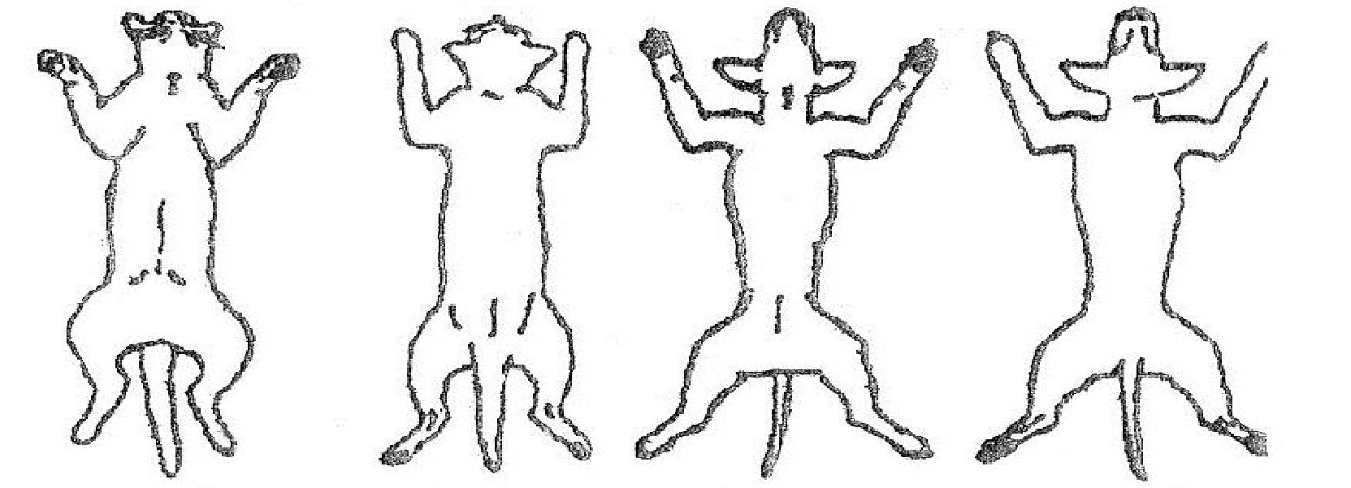
Please initial each paragraph once you have read, understood, and agreed to the terms:

________(Initial) I understand that Ancient Arts veterinarians are licensed veterinarians who focus their practice on alternative and holistic therapies including but not limited to: acupuncture, aquapuncture, herbs, flower essences, prolotherapy, nutrition/food therapy, routine lab work, NAET allergy elimination technique, homeopathy/homotoxicology, detoxification, aromatherapy, reiki, tui na massage, qi gong meditation, energy work, and the understanding of the human-animal bond.
(Circle or highlight all modalities listed that you are open to or would like to learn more about.)

________(Initial) I understand that Ancient Arts Veterinary Services, PLLC, currently does not offer surgery, dentistry, or radiographs but can provide a referral if these are needed or desired. I understand that alternative care is not a substitute but is a complement to routine veterinary care, including dental care. I understand that my own participation is essential in helping my pet. This includes but is not limited to providing appropriate social, psychological, hygienic, physical, emotional, spiritual, mental, and routine medical care for my pet, as well as myself. I understand and am open to learning more about how my own energy affects that of my pet and agree to conduct myself in such a way as to not disrupt the healing of my pet, or any other patients in the clinic (soft voices, no excessive/loud use of phone).

________(Initial) I understand that I am responsible for restraining my pet during acupuncture so that the needles are not pulled or shaken out. Please keep a harness or collar on your pet and keep them from hiding under or behind chairs!!!

________(Initial) I understand that Ancient Arts doctors always maintain their Hippocratic Oath to “above all else, do no harm” and work with the animals, not against them. This may mean that for some sensitive animals, subtle energetic techniques may be more appropriate than the use of acupuncture needles. Remember: each session is individual and may involve fewer or more needles or different treatment options than other sessions.

________(Initial) I will do my best to give 24-48 hrs’ notice for refills if I am not ordering them at a scheduled appointment.

________(Initial) I understand that Ancient Arts is not an emergency clinic, nor should it be a substitute for urgent needs. Therefore, I agree to the email and phone policy to await up to 48 hrs for replies from staff and to only call OR email once for the same request within that time frame. I understand that questions not pertaining to the most recent/initial visit will warrant a new exam.

________(Initial) I understand that if my pet has incontinence or is a marker, he/she will need to wear a diaper or Belly Band to their visit to maintain hygiene and comfort for all patients, clients, and staff. I understand that if my pet shows signs of aggression, is difficult to handle, or displays excessive barking, the staff may request a muzzle, gentle leader, or additional tools to keep everyone safe and give my pet the best evaluation and care.

________(Initial) I understand that opened, mixed, or hand-counted supplements, herbs, and medications cannot be refunded.

________(Initial) I understand that Ancient Arts veterinarians always do their utmost best to heal patients and there is never a guarantee as to the outcome, as is true with all medicine and all aspects of life. I understand that if my pet is to receive long term
herbs and/or supplements, a current doctor/patient relationship must be maintained by scheduling an exam at least once a year. If
________(Initial) I understand that payment is due at the time of services rendered and that there is a $30 fee for any returned checks.
________(Initial) I understand that if I arrive more than 10 minutes late or if I do not show up to my scheduled appointment, and/or if I fail to give at least 24 hours’ notice for cancelling or rescheduling an appointment, I will be charged a $50 fee for disregard of the doctor’s time and that of fellow clients who would have liked that appointment time slot.

________(Initial) If multiple No Shows or cancellations/reschedules have occurred with less than 24 hours’ notice, Ancient Arts Holistic Veterinary Services will require pre-payment for future appointments. These pre-paid appointments will have to be scheduled by phone during business hours or in person. (we will not accept pre-paid appointments by voicemail or online scheduling.) Not showing for a pre-paid appointment will result in forfeiture of pre-paid amount.

Signature: ________________________________________________________ Date: _____________________________

Print Name: ______________________________________________________

